House of Multidimensional Pain

Level Design Document

A funhouse style maze with seemingly impossible geometry. There are three different areas, each with its own puzzle to solve in order to progress to the next area. The look of the level will be a simple room. The feeling of an abandoned warehouse or hospital, a little spooky. With brick walls, old hard wood floors and exposed piping.

# Goals

* Disorient the player’s sense of direction without frustrating them outright
* A true sense of triumph and accomplishment at the end for figuring out the puzzles

# Map

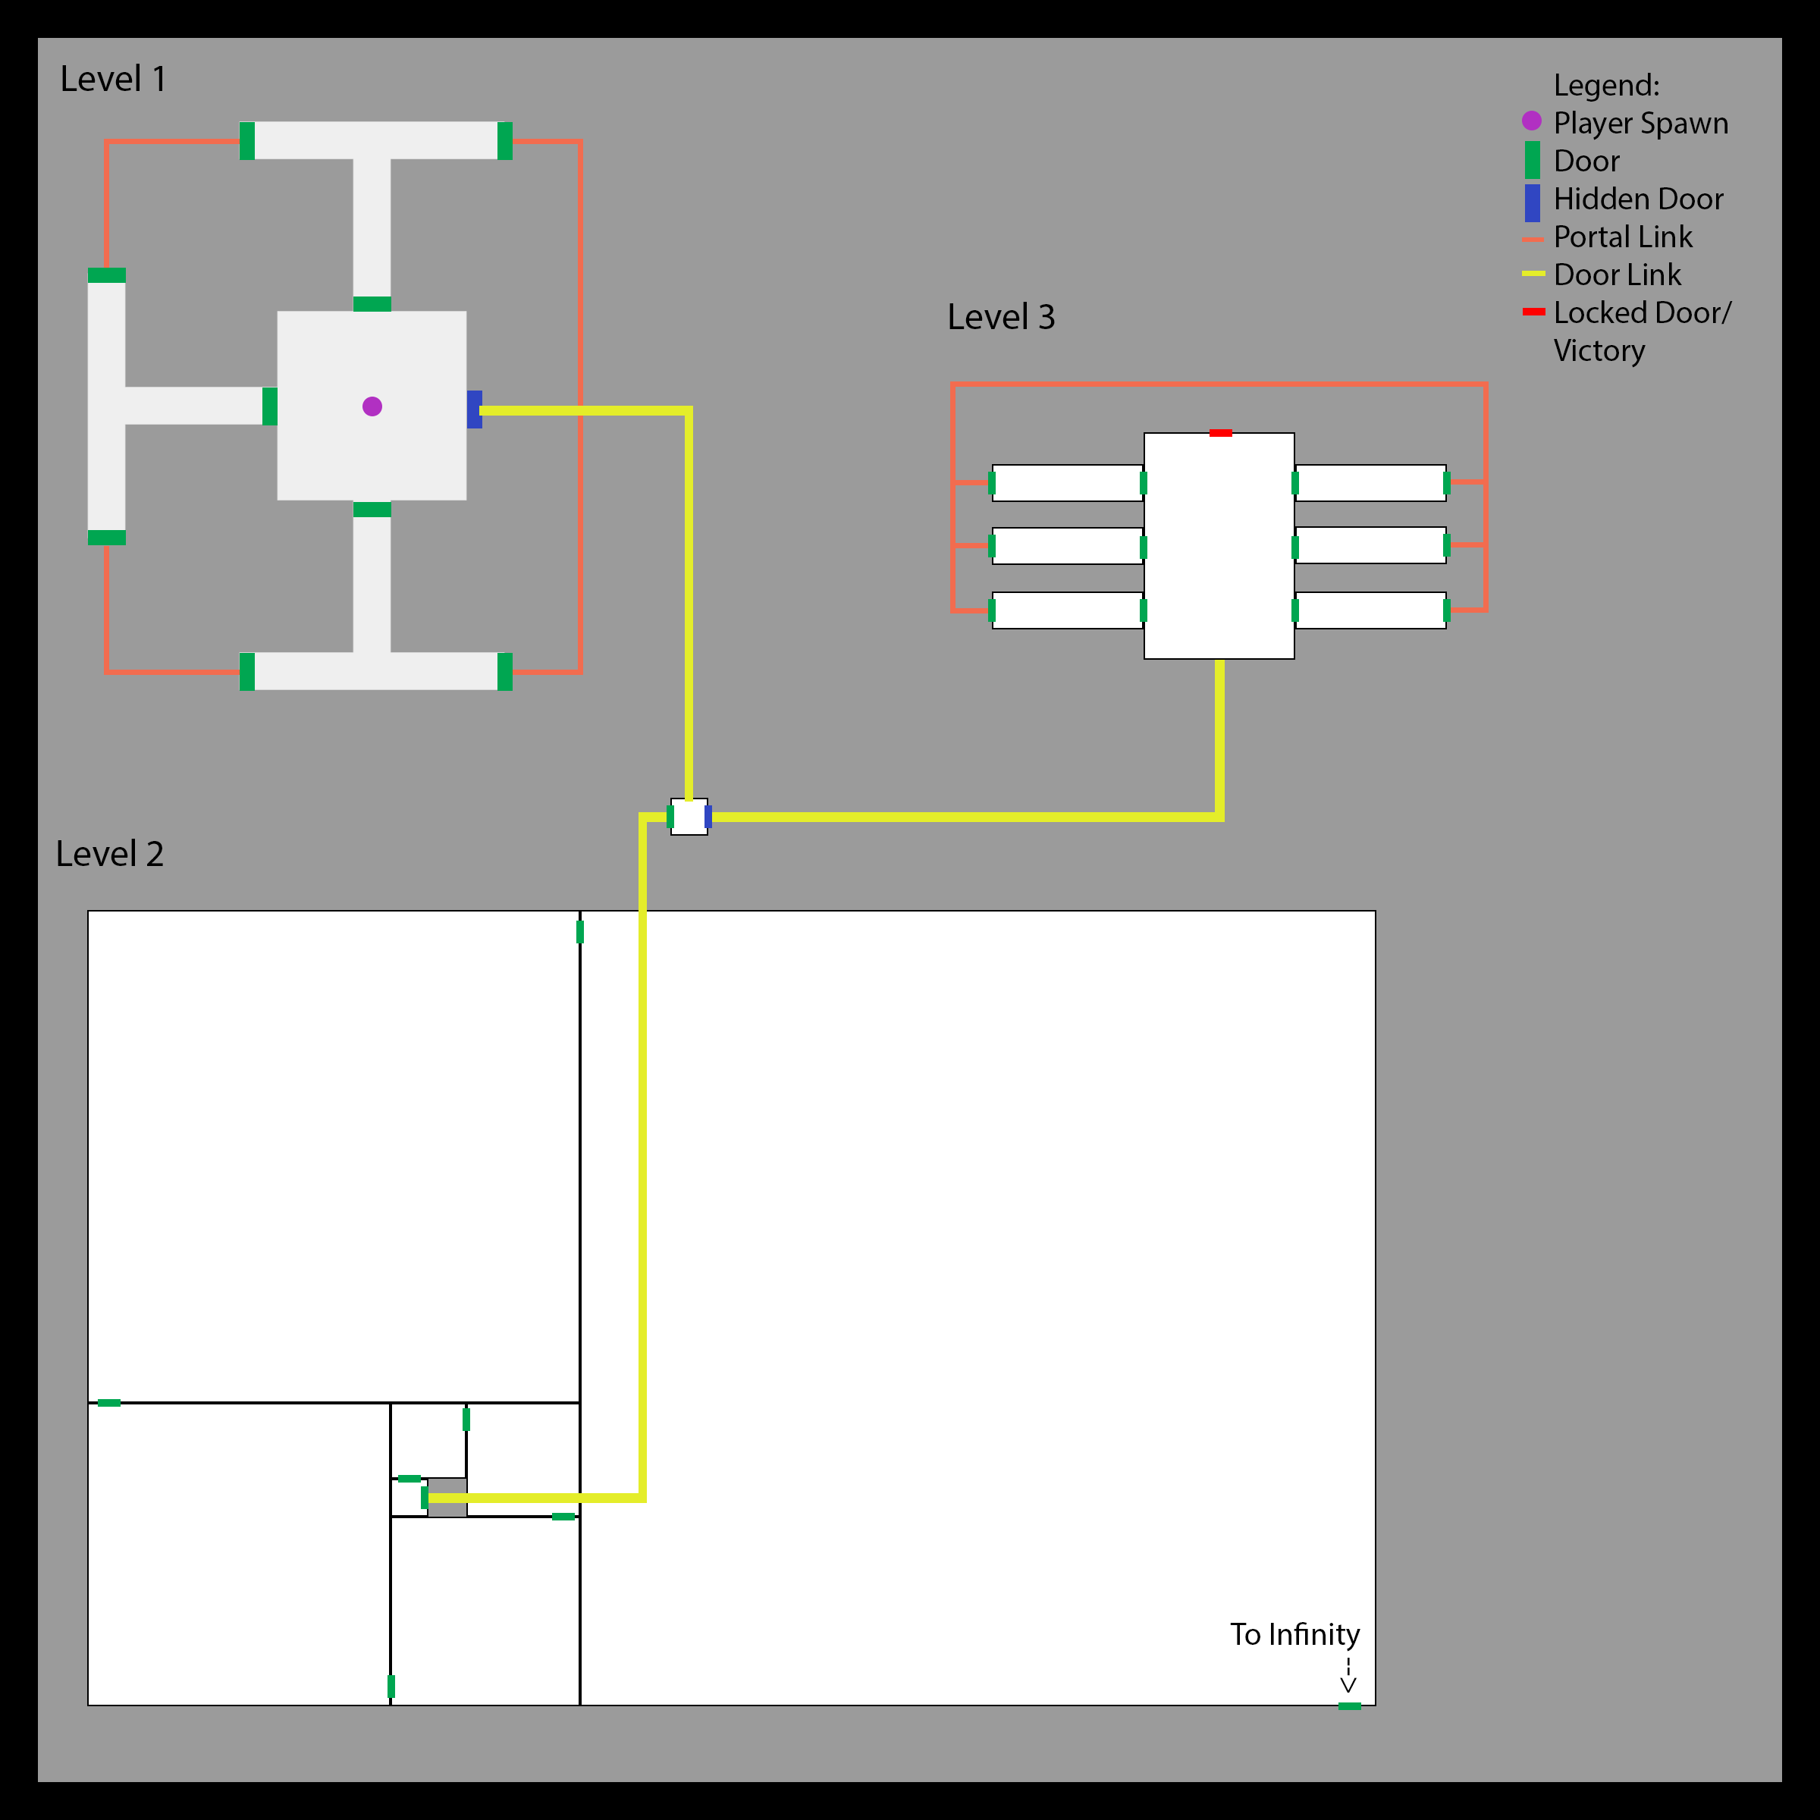

# Assets

|  |  |  |  |  |
| --- | --- | --- | --- | --- |
| **Asset Name** | **Description** | **Model?** | **Texture?** | **Done?** |
| BrickWall | Simple brick pattern on most walls. | Box | X | X |
| Door | Wooden or metal doors. | Box | X | X |
| Floors | Hardwood. | Plane | X | X |
| Ceiling | Hardwood? Stucco? | Plane |  |  |
| PipeLength | Straight length | Cylinder | X | X |
| PipeCorner | 90 degree corner | Custom | X | X |
| Pipe T | T junction connector | Custom | X | X |
| Window | Simple frame | Primitives |  |  |

# Reference images

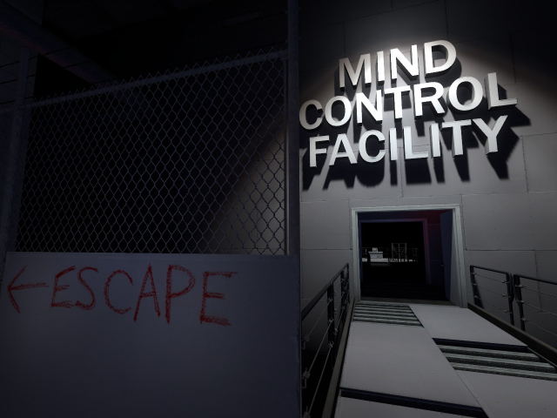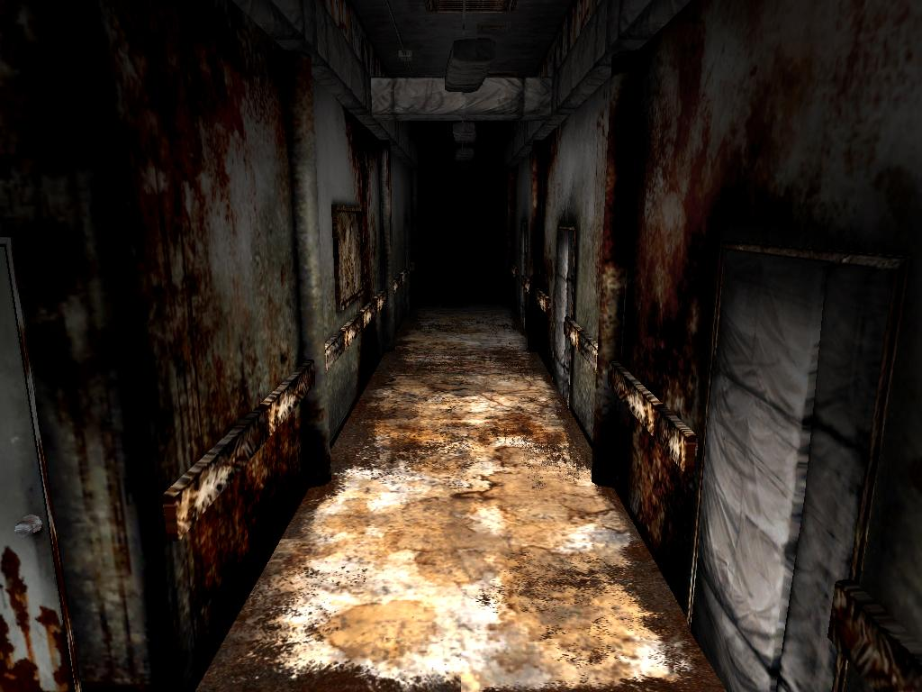

# Requirements

* Maze inspired by popular movie
* Enclosed (roof), but some scene extension
* One “interesting area” eye catching for player
* At least two props, sharing one with classmates
* Reusable assets, sharing with classmates